Civil war in Liberia

UNSC Resolution: | 985
Date of adoption: | 13-Apr-1995
Operative paragraph: | 5
Demand number: | 985,0511

Sarah-Myriam Martin-Brûlé

Wording of demand

participate (in a regional summit on Liberia)

List of addressees of the demand
- National Patriotic Front of Liberia, Government of Liberia, Central Revolutionary Council of the National Patriotic Front of Liberia, Lola Defence Force, Liberian National Conference, Liberian Peace Council, United Liberation Movement of Liberia for Democracy - Krahn, United Liberation Movement of Liberia for Democracy - Mandingo

Short-term compliance

Description of the addressee(s)’ conduct

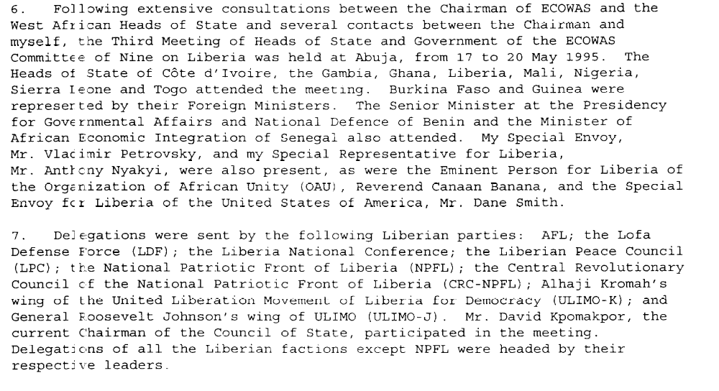

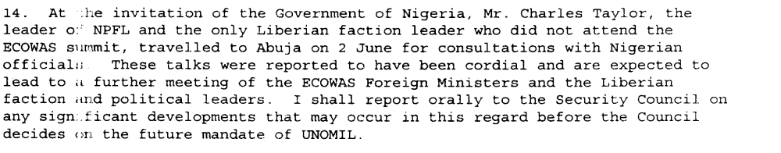

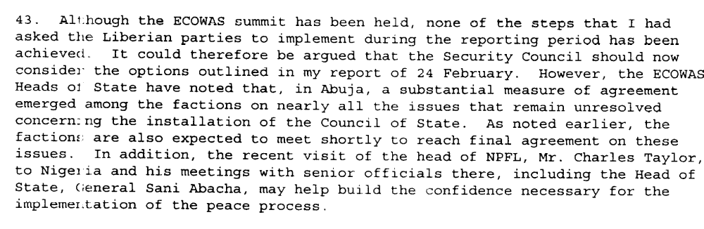
Eleventh Progress Report of the Secretary-General on the United Nations Observer Mission in Liberia, S/1995/473, 10 June 1995

Assessment

Short-term compliance
No or marginal compliance (1) | Medium low compliance (2) | Medium high compliance (3) | X Full or almost full compliance (4)

Considerations underlying the assessment

The demand addressees did participate on a regional summit on Liberia.

Medium-term compliance

Description of the addressee(s)’ conduct

“By the end of May, fighting in Monrovia had subsided, mostly for want of anything
left to loot; ECOMOG redeployed in the city as did many of the fighters. In August 1996, the main warlords were summoned to the Nigerian capital Abuja. There they signed the fourteenth peace agreement in the conflict. It became known as the Abuja II accord, as it supplemented the August 1995 Abuja Accord ('Abuja I'), which itself amended earlier agreements . ECOWAS countries, led by Nigeria, were embarrassed by ECOMOG's 6 April debacle and worried by instability in the sub-region. They gathered in an impressive consensus. Even Cote d'lvoire, Charles Taylor's old ally, cracked down on cross-border economic ventures. Abuja II also enjoyed strong backing from western governments who said it was Liberia's last chance for peace with donor support.”
(…)
“The warlords officially dissolved their factions, giving birth to follow-on political parties such as Charles Taylor's National Patriotic Party (NPP) and Alhaji Kromah's All-Liberian Coalition Party (ALCOP). An independent electoral commission (IECOM) was set up to oversee the preparation of the elections, initially set for 30 May.”
Tanner, Victor(1998)'Liberia: railroading peace',Review of African Political Economy,25:75,134.
http://pdfserve.informaworld.com/593228_770885140_769343427.pdf

Assessment

Medium-term compliance
No or marginal compliance (1) | Medium low compliance (2) | Medium high compliance (3) | X Full or almost full compliance (4)

Considerations underlying the assessment

The demand addressees did participate to the regional summit.

Depth of demand

Assessment

Level of depth of demand
X Low depth of demand (1) | Medium depth of demand (2) | High depth of demand (3)

Considerations underlying the assessment
Compliance with this demand neither put the survival of the demand addressees at a significant risk nor did it significantly impact on their chances to attain victory in the civil war or to win power in its aftermath.

Level of confidence about coding decisions

Level of confidence about coding decision
Extremely high | X High | Moderate

Comments to IPI (if any)

